News Release
for projected publication date of August 2, 2018 to August 9, 2018

Scottdale Mennonite Church
July 22, 2018
For additional information Contact
Scottdale Mennonite Church
801 Market Street
Scottdale, PA 15683
Phone 724-887-7470

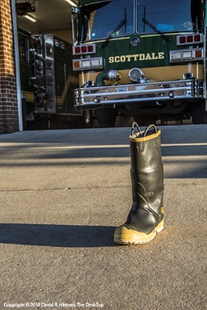
Local church initiates first responder appreciation day
On Sunday August 12, 2018 Scottdale Mennonite Church is introducing an open house for Scottdale and Everson first responders. The church invites the public to an Open House at Scottdale central fire station on Pittsburgh Street between the hours of 10:00 AM and noon.
One of three priorities of the church is to support local first responders, according to recent church council minutes. This open house is one way to show that appreciation.
On Sunday, August 12, 2018 from 10 AM to 12 noon the church is inviting the public to greet and meet first responders—firemen, policemen, ambulance personnel—at Scottdale Central Fire Station, Pittsburgh Street, Scottdale.
All ages are invited to stop in to meet and thank first responders including Scottdale police, Mutual Aid workers as well as Everson and Scottdale volunteer fire departments. Scottdale volunteer firemen will open the station and be on hand to answer questions. Everyone is encouraged to sign the giant “Thank You” cards at this time.
At least four Scottdale Mennonite members regularly support various aspects of the first responding. Brothers Ben Savanick and Nathan Savanick are active in the Scottdale fire department. Brian Howard is a Mt. Pleasant Fire Volunteer. Michael Butti is employed by Mutual Aid Ambulance Service.
Pastor Dave Mishler said the three priorities have grown out of congregational processes following a couple board retreats two years ago. “Individuals with a concern have motivated others to adopt their cause and three have stood out.”
This plan follows a Sunday last year when the Scottdale fire company parked a fire truck behind the Scottdale Mennonite church and the church served an informal breakfast.
“The first responders do so much for our community. We wanted to organize an event that tells them how much we appreciate that” said Audra Shenk, former owner of Brilhart Hardware and church member.
A Boot Drive is also being organized for the two volunteer fire departments. Local churches are passing the boot during their worship service and will bring those donations to the Open House. The public may also contribute at this time by stopping in or driving by the station.
“We want the local community to see that our church supports everyone. We especially appreciate the help and neighborly responses from our first responders,” said David Hiebert, member of the peace and mission committee of the church.
The Scottdale Mennonite Church was formed in the early 2000s as a merger of the former Kingview Mennonite and Mennonite Church of Scottdale. Currently about 50 members worship each Sunday. Mennonites were some of the first European settlers in southwestern PA. World-wide, Mennonites are known for their service ethic, stance on pacifism/world peace and following Jesus in daily life.
--end--
Photo caption: A fireman’s boot on the approach outside the Central Fire Station, Scottdale, PA reminds us of the service and dedication of firemen and other first responders. Each local Scottdale congregation will receive a boot to collect a supportive offering. The offerings and other donations may be presented at an open house on August 12, 2018. Photo by David R. Hiebert
Link to reproduction sized boot image [yes you may use this © photo in relation to this event and news].
http://historic-maps.net/Scottdale-Mennonite/c.IMG_2318.jpg

